|  |  |  |
| --- | --- | --- |
| NavVision Technical Description | | |
|  | | |
|  | |  |
|  |  | |

|  |  |  |  |
| --- | --- | --- | --- |
| Publication typet: | | NavVision Technical Description | |
| Publication number: | | ACC | |
| title: | |  | |
| Sub title: | |  | |
| Issue: | | 1.2.17 | |
| Date: | | 28 November 2013 | |
| Total number of pages: | |  | |
|  | |  | |
|  | |  | |
| Author: | |  | |
| Approved: | |  | |
|  | |  | |
|  | |  | |
|  | |  | |
|  |  |  |  |
|  |  |  |  |
|  |  |  |  |
|  |  |  |  |

Table of Contents

Page #

Tables 7

References 8

Abbreviations 8

Updates 9

1. Purpose of document 10

2. System overview 11

2.1 Introduction 11

2.2 AMCS architecture 12

2.2.1 Duty Alarm Panel 14

2.2.2 Local Processing Units 15

2.2.3 Coupler 16

2.2.4 Local Area Network 16

2.2.5 Printers 18

2.2.6 Redundancy 18

2.2.7 VDR Interface 18

3. System functionalities 19

3.1 Alarm handling and presentation 19

3.1.1 Alarm acknowledge 21

3.1.2 On duty indication 21

3.1.3 Alarm inhibits 22

3.2 Distributed database 22

3.3 Data flow 22

3.4 Standardized control functions 24

3.5 Serial connections to third party devices 24

3.6 Built-in failure detection 24

3.7 Data logging 24

4. Sensors and controls 27

4.1 Sensors 27

4.1.1 Analogue sensors 27

4.1.2 Digital sensors 27

4.1.3 Serial sensors 27

4.2 Sensor priority 28

4.3 Sensor calibration 28

4.4 Sensor alarm settings 28

4.4.1 Sensor alarm groups 28

5. I/O-stations 29

5.1 Components 29

5.1.1 Local Processing Unit 29

5.1.2 Network switches 29

5.1.3 Power supply 30

6. Workstations 31

6.1 Workstation versions 31

6.1.1 Workstation 31

6.1.2 Duty Alarm Panel 32

6.1.3 Operating system 33

6.1.4 Connection to I/O-stations 34

6.1.5 Power supply 34

7. Human Machine Interface 35

7.1 Taskbar 35

7.1.1 Mimics and screens 37

7.2 User rights 37

7.2.1 Instruments and indicators 38

7.2.2 Analogue, digital and graphical instruments 38

7.2.3 Indicators 40

7.2.4 Bar graph display 40

7.2.5 Diagrams 41

7.2.6 Buttons/switches 41

7.2.7 Meters 42

7.3 Config list 42

7.4 Layouts 43

7.5 Colour usage 43

8. Mimics 44

8.1 Introduction 44

8.2 Colour coding 44

8.2.1 Symbols 44

8.2.2 Control elements 46

8.2.3 Pump and generator control elements 47

8.2.4 3- Way valve control element 48

8.3 Functional description 50

8.3.1 Measuring and control of Fresh Cooling Water (FCW) temperature 50

8.3.2 Alarm and monitoring of main engine exhaust gas system 51

8.3.3 Tank measurement system 52

9. Duty alarm system 53

9.1 General 53

9.1.1 Attended alarm mode 53

9.1.2 Unattended alarm mode 53

9.1.3 How an alarm is displayed 54

9.1.4 How to acknowledge an alarm 55

9.1.5 When an alarm is not acknowledged within a specific period of time 55

9.1.6 How to silence an alarm (not at ECR) 55

9.1.7 When will an alarm disappear 55

9.1.8 Duty Alarm Panel (DAP) 56

9.2 Duty Alarm Panel functionalities 58

9.3 On duty select procedure 60

9.4 Alarm acknowledge procedure 60

9.5 Call function 61

10. Personnel alarm 62

10.1 General 62

10.1.1 Release station 62

10.1.2 Timer reset station 63

*: A personnel alarm system can also consist out of mushroom buttons for the timer reset and entrance panels for the machinery space. The on/off function will then be performed on screen with a code*Alarm monitoring and control process 63

Appendix A - System architecture 65

Appendix B - Technical data sheets 66

Figures

Figure 2‑1: AMCS block diagram 12

Figure 2‑2: Duty Alarm Panel 14

Figure 2‑3: Local Processing Unit (WAGO) 15

Figure 2‑4: Coupler 16

Figure 2‑5: Logbook 17

Figure 3‑1: Alarm presentation 20

Figure 3‑2: Alarm bar 20

Figure 3‑3: Field Data Package 23

Figure 3‑4: Serial interface 24

Figure 3‑5: Logbook 25

Figure 5‑1: Local Processing Unit 29

Figure 5‑2: Network switch 30

Figure 6‑1: typical Workstation 31

Figure 6‑2: Duty Alarm Panel (DAP) 32

Figure 6‑3: Traditional OS structure 33

Figure 6‑4: NavVision embedded OS structure 33

Figure 7‑1: NavVision taskbar 35

Figure 7‑2: Example mimic 37

Figure 7‑3: Analogue/digital/graphical instrument 39

Figure 7‑4: Indicators 40

Figure 7‑5: Bar graph display 40

Figure 7‑6: Trend diagrams 41

Figure 7‑7: Buttons 41

Figure 7‑8: Meter 42

Figure 7‑9: Config list 42

Figure 7‑10: Electrical distribution mimic 43

Figure 7‑11: Tank level mimic 43

Figure 8‑1: Mimic layout 45

Figure 8‑2: Measuring and control of FCW temperature 50

Figure 8‑3: Exhaust gas temperature measurement 51

Figure 8‑4: Tank measurement 52

Figure 9‑1: Alarms on alarm viewer and taskbar 54

Figure 9‑2: One acknowledged and three unacknowledged alarms (incl. GEA) 55

Figure 9‑3: Duty Alarm Panel (DAP) 56

Figure 9‑4: Alarm and status area 56

Figure 9‑5: Alarm groups 56

Figure 9‑6: Bridge watch 57

Figure 9‑7: Operating buttons 57

Figure 9‑8: On duty indication 57

Figure 9‑9: Bridge watch safety timer 57

Figure 9‑10: Engine room watch safety timer 57

Figure 9‑11: Engine room watch button 57

Figure 9‑12: Call button 58

Figure 9‑13: Acknowledge button 58

Figure 9‑14: Panel active button 58

Figure 9‑15 Duty Alarm Panel (on duty select) 60

Figure 9‑16 Duty Alarm Panel (call function) 61

Figure 10‑1: Release station 62

Figure 10‑2: Timer reset station 63

Tables

Table 3‑1: Alarm presentations 21

Table 3‑2: Static and dynamic data 23

Table 3‑3: Data logging 25

Table 3‑4: Display information colours 25

Table 3‑5: Logbook buttons 26

Table 4‑1: Analogue sensors 27

Table 4‑2: Digital sensors 27

Table 4‑3: Sensor priority list 28

Table 4‑4: Sensor alarms 28

Table 7‑1: NavVision rights 38

Table 7‑2: Configuration features (instruments and indicators) 38

Table 8‑1: Colour markings of pipes 44

Table 8‑2: Control element status 46

Table 8‑3: Colour codes (control elements) 47

Table 8‑4: Control elements and colour animation 48

Table 8‑5: Control elements with status indication 49

Table 8‑6: Control elements with speed indication 49

Table 8‑7: Other control elements 49

Table 8‑8: I/O declaration (FCW temperature) 50

Table 8‑9: I/O declaration (engine exhaust gas system) 51

Table 9‑1: Duty Alarm Panel functionalities 59

Table 10‑1: Release station buttons 62

Table 10‑2: Alarm monitoring and control process 64

References

Not applicable.

Abbreviations

|  |  |
| --- | --- |
| ABS | American Bureau of Shipping |
| ACS | Automation Control Sequences |
| AI | Analogue Input |
| AMCS | Alarm, Monitoring and Control System |
| AO | Analogue Output |
| AUT | Automation systems |
| BIT | Built-in-Test |
| BV | Bureau Veritas |
| CAN | Controller Area Network |
| CCTV | Closed-Circuit Television |
| COTS | Commercial Of The Shelf |
| CPU | Central Processing Unit |
| DAP | Duty Alarm Panel |
| DC | Direct Current |
| DNV | Det Norske Veritas |
| DI | Digital Input |
| DO | Digital Output |
| DPR | Disturbance Printer |
| ECR | Engine Control Room |
| FT | Free Technics |
| GEA | General Engineer’s Alarm |
| GL | Germanischer Lloyd |
| HMI | Human Machine Interface |
| IAS | Integrated Automation System |
| IEC | International Electrotechnical Commission |
| IM&O | Imtech Marine & Offshore |
| IMO | International Maritime Organization |
| INT | Interface |
| IO | Input/Output |
| JPT | Journal Printer |
| KR | Korean Certification |
| KTC | Keyboard Trackball Combination |
| LAN | Local Area Network |
| LED | Light Emitting Diode |
| LPT | Line Print Terminal |
| LPU | Local Processing Unit |
| LR | Lloyds Register |
| MAC | Media Access Control |
| MIMIC | Process graphic |
| MTR | Monitor |
| NKK | Nippon Kodoshi Corporation |
| NWS | Network Switch |
| NMEA | National Marine Electronic Association |
| WORKSTATION | Workstation |
| OS | Operating System |
| PAE | Personnel Alarm Entrance |
| PAR | Personnel Alarm Reset |
| P&ID | Piping & Instrumentation Diagram |
| PLC | Programmable Logic Controller |
| PMS | Platform Management System |
| RINA | Royal Institute of Naval Architects |
| SCADA | Supervisory Control And Data Acquisition |
| SOLAS | Safety of Life at Sea |
| SUB | Substation |
| TCP/IP | Transmission Control Protocol/Internet Protocol |
| TFT | Thin Film Transistor |
| TRB | Trackball |
| UDP | User Datagram Protocol |
| UPS | Uninterrupted Power Supply |
| USB | Universal Serial Bus |
| VDR | Voyage Data Recorder |

Updates

Underneath are the updates indicated of those parts, which have been changed related to the previous release.

|  |  |  |  |
| --- | --- | --- | --- |
| **Issue** | **Date** | **Change** | **Reason** |
| 1.0 | Mar. 5, 2010 | First release |  |
| 2.1 | Jan. 17, 2013 | Modified |  |
| 1.2.17 | November 27, 2013 | Modification | ACC |

# Purpose of document

This document contains the functional specification of the Alarm, Monitoring and Control System (AMCS) which is developed by Free Technics and known as NavVision. It separately describes the “Duty alarm system” and “Personnel alarm”, which are integral parts of the AMCS.

NavVision is a modular, integral hard- and software solution for the maritime industry. It replaces all instrumentation, switchboards, alarm panels, and allows computer control and monitoring of all data and equipment such as engines, generators, pumps, refrigeration systems, hydraulic systems and navigational sensors, etc.

The scope of the functional specification is seagoing cargo vessels with an unmanned machinery space for 24 hours minimal (AUT[1] notation).

# System overview

## Introduction

NavVision Alarm Monitoring and Control System (AMCS) is responsible for the full-time alarm, monitoring & control of a ship’s platform. That is, the actual status of platform objects is monitored and verified against a desired state. In case of undesirable platform behavior the AMCS will notify the operator by issuing an alarm via the Human Machine Interface (HMI). Moreover if the alarm endangers critical systems then the AMCS is able to react via the operator. This means that AMCS is able to control the relevant platform object to prevent further damage and alternately control another platform system (if applicable) to recover. This is known as the automation control level.

In addition, AMCS supports remote platform control by operators. It is possible to control an actuator on the platform from an AMCS Workstation by issuing relevant controls. The AMCS supports several hierarchical operating levels of the various platform systems:

* **Remote control**   
  The AMCS offers remote control of equipment and platforms per Workstation by setup. This remote AMS control can be both open-loop manual control, and closed-loop automatic control.
* **Supervisory control level (management facilities)**  
  Support facilities are provided for manipulating the configuration of the AMCS in terms of operator tasks and availability of components etc. This cannot be performed by a normal operator, but must be done by an authorized operator.

## AMCS architecture

The Alarm Monitoring and Control System (AMCS) is primarily used to monitor a ship’s platform (see Figure 2‑1). Platform statuses and alarms are to be visualized to the AMCS operators via the Human Machine interface (HMI). Besides this operators are able to control the platform via the HMI.

The HMI is based on integrated software that runs on each Workstation. Depending on the configuration, the software can act as a server, client or alarm viewer. For the scope of the type approval process, One Workstation is configured as Server. The rest of the Workstations are configured as Failsafe clients or normal client..

An AMCS server periodically gathers platform data from each Local Processor Unit (LPU) via the Local Area Network (LAN) and stores it in its local memory. The network topology is fail-safe. Each I/O (Input/Output) station has two network connections and two power sources. Whenever a Workstation needs certain data to visualize platform statuses then it will request the AMCS server for this data. As a result the AMCS server will broadcast the data in concern via the LAN. The server with the master role and up and running is responsible for the central alarm management and control. All failsave clients can also monitor equipment.

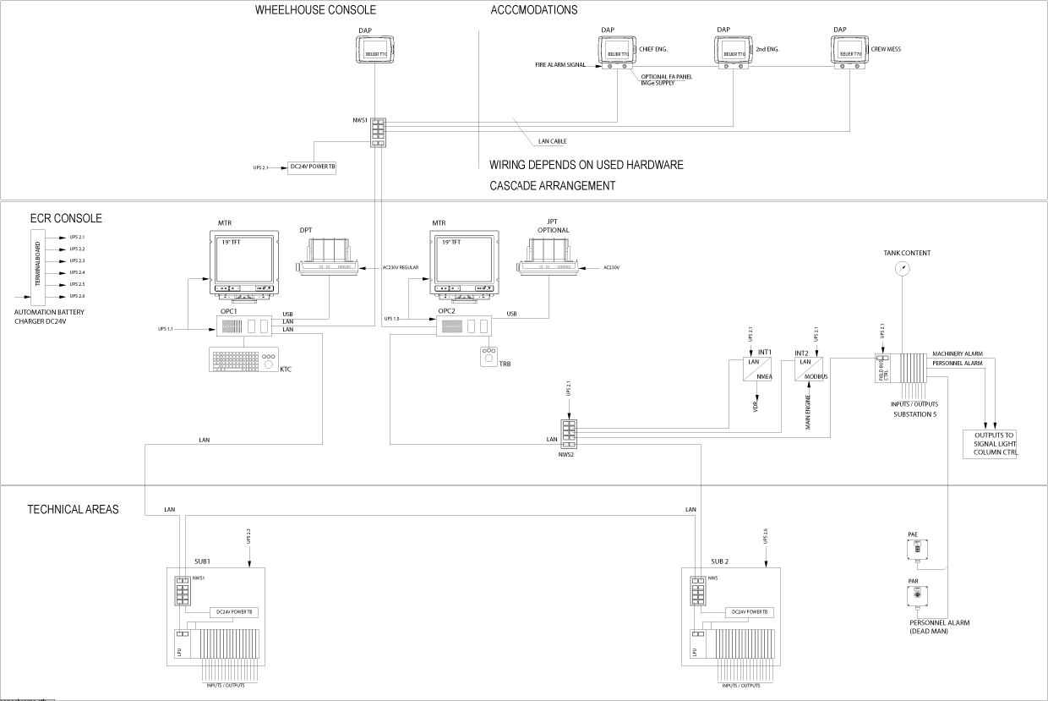

Figure 2‑1: AMCS block diagram

Since any failure of either the Workstation or LAN is likely to disturb the transfer of data from the platform to the AMCS operator or vice versa all these sub‑systems shall feature redundancy to achieve graceful system degradation.

AMCS server redundancy is achieved by installing at least two computers each of them capable of running the NavVision software in server mode (failsave client wil act as server as soon as the server stops working). The failsave AMCS client automatically takes over the master server role in case the master AMCS server unexpectedly goes to offline.

Whenever an AMCS operator originates controls for a certain platform object from his Workstation then relevant control signals will immediately be sent over to all AMCS clients via the LAN. However only the master AMCS server will forward the commands to the local Processing Unit (LPU) involved with the processing of that platform object.

Each AMCS Workstation whether it is running as a client or a master will also be capable of storing a (limited) set of data into a database to serve the alarm summary and history. This information might be of help in case analysis on historical platform behavior is needed (see chapter 3.7).

Each Workstation will be equipped with at least one Thin Film Transistor (TFT) monitor (MTR) and trackball (TRB). Optionally a keyboard trackball combination (KTC) can be applied.

Each Workstation will be equipped with two network interface cards both acting as a team in a switch fault tolerant mode. As each out of both network connections will be connected to a unique Ethernet switch (SW1 and SW2) a redundant connection to the LAN is achieved (Appendix A).

### Duty Alarm Panel

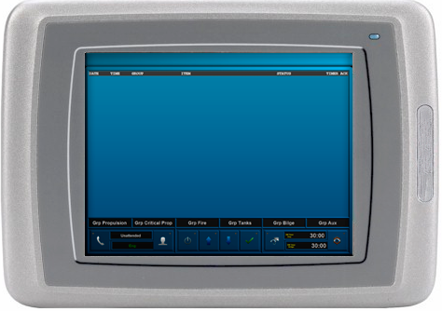

Figure 2‑2: Duty Alarm Panel

A Duty Alarm Panel (DAP) is used to display alarms. NavVision uses a 6.5" touch screen (640 x 480 pixels) which allows for direct interaction with the alarm panel and is used for navigating through present alarms and to silence them. The DAP is driven by a small industrial computer running an embedded operating system.

### Local Processing Units

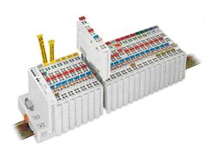

Figure 2‑3: Local Processing Unit (WAGO)

The Local Processing Units (LPU’s) are used to interface the platform (by sensors and actuators) by means of Commercial of the Shelf (COTS) equipment. Each LPU comprises a Programmable Logic Controller (PLC) and a number of I/O[2]‑modules. For I/O interfacing with NavVision, the WAGO-I/O-system is used.   
The system is optimized for process-oriented communication and is a scalable-performance solution for high integration density. The system has been approved by:

* Germanischer Lloyd (GL),
* Lloyds Register (LR),
* American Bureau of Shipping (ABS),
* Bureau Veritas (BV),
* Det Norske Veritas (DNV),
* Royal Institute of Naval Architects (RINA),
* Korean Certification (KR),
* Nippon Kodoshi Corporation (NKK).

The I/O-system features different types of modules, like digital and analogue I/O and counters. When linked together (by simply placing them next to each other), the modules form a bus that transports the collected data of all modules to a head station. This head station in turn places the collected data onto the Ethernet network using its Local Area Network (LAN) connection.

Because of its modular design, a defective I/O module (or slice) is easily replaced by removing the defective slice and replacing it with a new one of the same type. After a power reset, to prevent unwanted Programmable Logic Controller (PLC) behavior, the configuration of the old slice is automatically written to the new slice, where after normal operation can continue as if nothing ever happened.

### Coupler

PLC head stations (also called couplers) that plug into the front of the PLC modules offer fast replacement. By giving in the correct MAC[3]-address of the specific I/O head station, the configuration will start automatically (after a power reset). As a troubleshooting aid, status indicators are provided on the front of modules for indication of fault status.

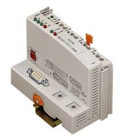

Figure 2‑4: Coupler

Programming of the application is performed in accordance with IEC 61131-3 “Programmable Controllers”. Free Technics (FT) can program the PLC for the TCP/UDP[4] transport protocol via Socket - Application Programming Interfaces (APIs).

Characteristics and use:

* Use of decentralized control enhances support of a PLC or PC in case of broken communication links
* Programmable response in the event of a field bus failure
* Signal pre-processing reduces field bus transmissions
* Peripheral equipment can be controlled directly, resulting in fast system response times.

### Local Area Network

The Local Area Network (LAN) provides a generic communication path. Ethernet (or the TCP/IP protocol) is the main means of communication and transmission throughout the system. More precisely: Ethernet takes care of the link between the Workstation’s/switches and monitoring units (e.g. sensors).

The monitoring units however are not bound to the TCP/IP protocol for gathering and transmitting data. NavVision supports the additional protocols Mod Bus[5], CAN Bus[6], J1939[7] and NMEA[8].

Using Serial-LAN converters, the serial data is ported to the TCP/IP protocol, making the data accessible to all Workstation’s on the network.

Whenever a connection is broken, the event is registered by NavVision. By noticing which part and its dependencies are no longer connected, it is able to deduce which network cable is faulty. Power supplies can also be monitored, the relevant information is then written into the logbook. When defined during the initial configuration, any lost connection will generate an alarm. Repaired connections are also detected and written to the system's log.

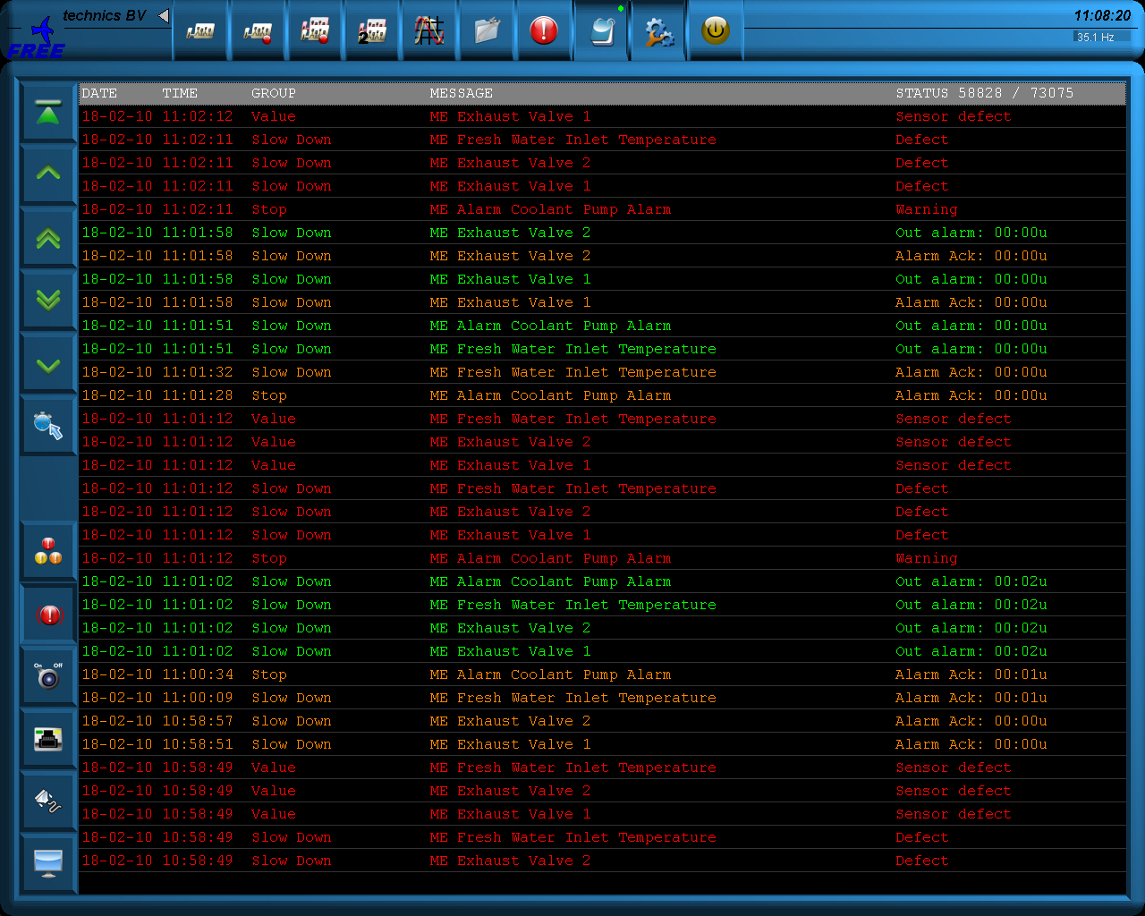

Figure 2‑5: Logbook

### Printers

Printers (DPT and JPT) are accessible via the LAN by each Workstation. From the AMCS point of view printers can be used in order to create hardcopies from mimics, historical event summaries (i.e. alarm history), trends, reports etc. Printers can be connected to Workstations by means of serial interfaces (COM ports) or to the network by means of a serial to lan interface

### Redundancy

The AMCS system offers redundancy. Each individual Workstation is able to take over AMCS functions of another workstation (except for the real clients as for instance DAP’s). In case a Workstation fails, one of the other Workstation of the system can take over the functions that were being performed. The redundancy is maximized at this moment through 52 AMCS Workstations in a normal installation. The failsafe-client Workstation can be used as a fully operational Workstation server except that it does not take over redundancy.

Each I/O cabinet is redundantly connected to the Ethernet. Failures in one of the network switches or connection cables will not affect proper functioning of the installation. The operator will be notified of the fault, while still being able to utilize the affected I/O units.

The Ethernet network is based on a ring network topology, ruling out single points of failure as much as possible. When one of the network cables fails, the network data traffic will be redirected to one of the other servers, to be automatically appointed as the master server on that time.

Redundantly available platform systems are connected to different separate PLC’s or I/O units of the system. In case of failure of one of these units, the affected platform system will not be available in the AMCS; however, the back-up platform system shall still be available in the AMCS. In this way, the applicable function is still available, with possibly a reduced capacity.

For vital platform components, on requirement, the Workstation provides hardwired (emergency) indications and controls. These indications and controls are directly connected to the appropriate platform component. In case of any failure in the Workstation, the vital control and monitoring tasks can still be performed via these direct indications/controls.

### VDR Interface

In a standard configuration the AMCS outputs data to a Voyage Data Recorder (VDR), which is not in the scope of this functional specification.

A VDR is a data recording system designed for vessels required to comply with the IMO's[9] International Convention SOLAS[10] requirements - IMO Res.A.861(20)[11] in order to collect data from various sensors on board the vessel. It then digitizes, compresses and stores this information in a protective storage unit.

# System functionalities

## Alarm handling and presentation

Alarm handling and presentation has the purpose to draw the operator’s attention in case of an undesirable situation or fault occurrence firstly by means of an audible signal and secondly by visualizing a relevant alarm message on the AMCS alarm page. Information on alarms is entered into the alarm log with details of acknowledgements and alarm status.

The alarm handling and presentation is one of the major AMCS functions. Machinery, safety and control faults are to be indicated at the relevant alarm stations[12] to warn personnel about an undesirable condition.

The alarm presentation has the functionality to present the operator an overview of the existence of undesirable situations or faults in machinery and equipment, safety and control systems. In addition, this function administrates the alarm notifications. Information on alarms is entered into the alarm log with details of acknowledgements and alarm status.

Three states can be distinguished for the alarm presentation:

* **Non-rectified and unacknowledged**  
  Non-rectified alarm notifications are messages indicating an alarm condition that currently exists.
* **Rectified and unacknowledged**  
  Rectified alarm notifications are messages indicating a previously detected alarm condition that is no longer in effect because the system has recovered from the alarm condition.
* **Non-rectified and acknowledged**

Alarm notifications have to be acknowledged by an authorized operator at one of the stations allowed to control that specific alarm. Unacknowledged alarm notifications may be either non-rectified or rectified and may change from non-rectified into rectified while the alarm notification remains unacknowledged. Rectified and acknowledged alarms are automatically removed from the alarm presentation.

The AMCS features different ways to notify an AMCS operator:

* **Alarm presentation**  
  The operator-in-control has the tasks to operate and guard the platform groups that are allocated to him. Whenever an alarm is issued on his station a local audible signal will be activated to draw the operator’s attention. On the event of an alarm signal the operator is assumed to switch to the AMCS alarm page. The alarm presentation page offers an overview of all alarms and warnings being issued (firstly sorted by “acknowledged”/ “unacknowledged” state and secondly by alarm generation timestamp) within the operator’s scope-of-control. The scope-of-control refers to the current assignment of alarm groups for each alarm station.

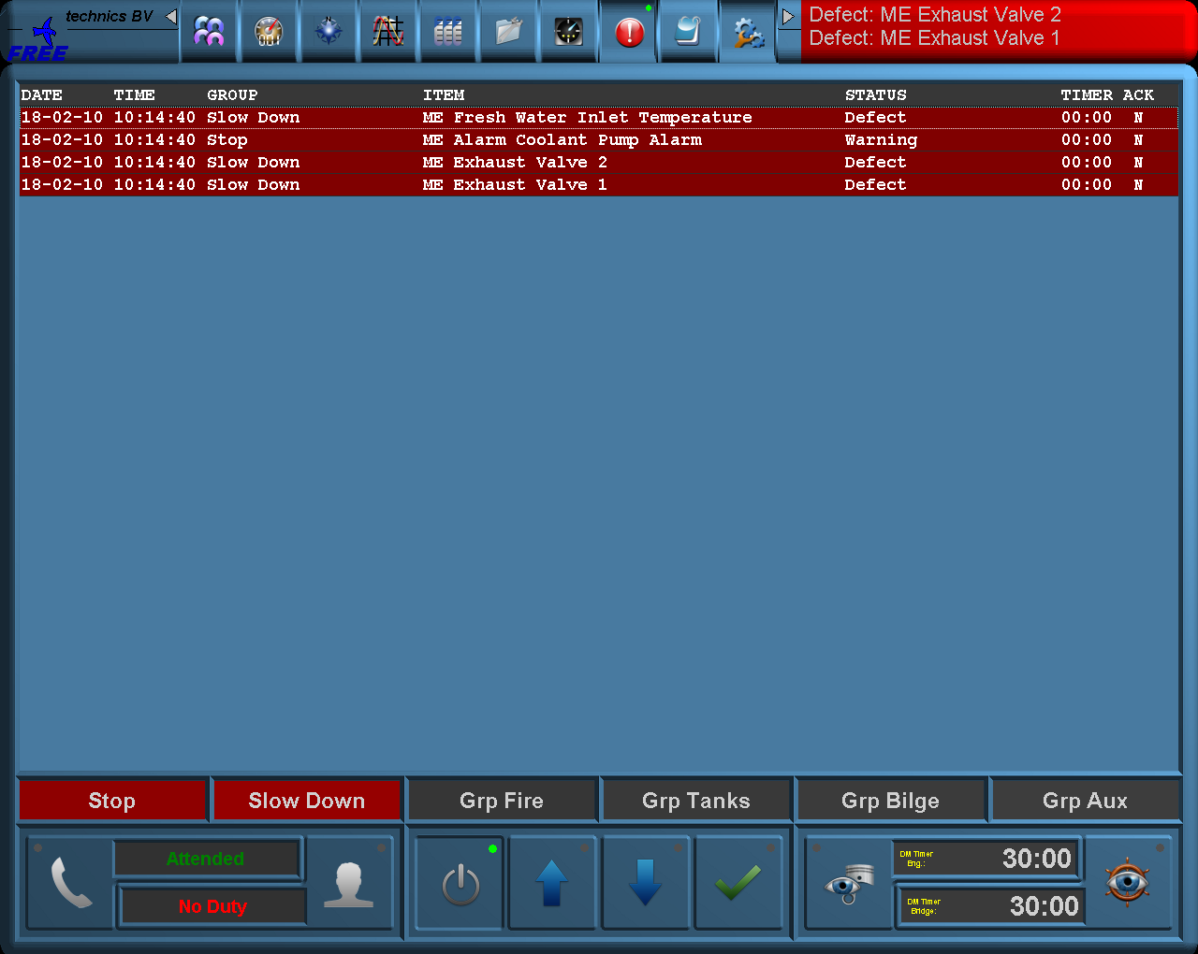

Figure 3‑1: Alarm presentation

* **Alarm bar**  
  The alarm bar provides an alarm existence at a glance for an operator, specific for the assigned alarm groups. Every task bar will comprise an alarm bar as described that provides a global view on available alarms on all Workstation’s.

ڣ°

Figure 3‑2: Alarm bar

Table 3‑1 explains the differences between these alarm presentations.

|  |  |  |
| --- | --- | --- |
|  | **Alarm presentation** | **Alarm group bar** |
| Available at | All AMCS operator stations with control facilities (stations-in-control) | All Workstation’s |
| Presentation | On operator demand | Always on top of the display |
| Alarm acknowledgement | At Workstation -in-control | Not supported |
| Visual alarm information | At Workstation-in-control:  All alarms of installation groups that are allocated to the station | Alarm existence in the applicable function group |
| Audible signal | An audible alarm sounds at the Workstation when an unacknowledged alarm is detected by the system in one of the allocated installation groups  Also all public spaces will have the same audible alarm  Silence of audible signal is not to extinguish visual alarms | An audible alarm sounds at the Workstation when an unacknowledged alarm is detected by the system and the audible slave function is enabled on the Workstation  Silence of audible signal is not to extinguish visual alarms |
| Silence audible signal | The audible alarm will cease when the alarm is acknowledged on the system or when a silence horn/buzzer command is given. | The audible alarm will cease when a silence horn/buzzer command is given. |
| Sort order | Unacknowledged state on top  Latest occurrence on top | Unacknowledged state on top  Latest occurrence on top |
| Filtering | Filtering on installation group allocation valid for the station | Filtering on installation group |

Table 3‑1: Alarm presentations

### Alarm acknowledge

Each alarm message is to be acknowledged by the Workstation within 5 minutes otherwise a General Engineers Alarm (GEA) will be issued. Output on the AMCS is to be provided to control an external equipment like horns/buzzers, flashlights etc.

### On duty indication

Please refer to chapter 8.

### Alarm inhibits

Certain platform events may cause irrelevant platform alarms under certain circumstances. For example a lubrication oil pressure sensor may issue a “Low pressure” alarm as soon as the lubrication pump is switched off, because the engine has been stopped. In that case the alarm is assumed to be spurious.

Since these spurious alarms will cloud the alarm list and so the operator view on the platform state, NavVision supports alarm inhibits. Whenever alarms are inhibited the alarm messages will be suppressed. Alarm inhibit equations are to be defined in the NavVision application.

## Distributed database

NavVision uses a distributed database which is present in the memory of each Workstation which is configured as a server or a failsafe-client. All sensor data and settings are stored in this database (see chapter 3.1). The database is continuously synchronized with other servers, with an update rate of 10 times per second.

Data is stored and used based on its timestamp. That means that NavVision uses the data with the latest timestamp. If one server would fail, i.e. because of a broken network link, the newest data present across the network will be used.

## Data flow

Each sensor read-out is connected to a so-called “Field” in the NavVision software. Such a field is a collection of values (or data package) relating to the configuration & current status of the sensor readout. You can see such a “field” as an element for a specific I/O.

Fields consist of both “Static data” and “Dynamic data”. Static data store the configuration of the sensor readout and is typically edited only once (during install), whereas the dynamic data is updated whenever the sensor readout changes.

Table 3‑2 shows the values carried in each field data package.

|  |  |
| --- | --- |
| **Static data** | **Dynamic data** |
| Timestamp | Sensor value |
| Range of value | Current value |
| Type of data (pressure, temperature, etc.) | Desired value |
| Filter time | High alarm status |
| Default value | Low alarm status |
| Default unit (mBar, °C, etc.) | Too high alarm status |
| Sensor calibration | Too low alarm status |
| Alarm levels (too low / low / high/ too high) | Defective status |
| Label | Available status |
| Comment | Low speed/high speed status  Local status  Remote status  Auto status |

Table 3‑2: Static and dynamic data

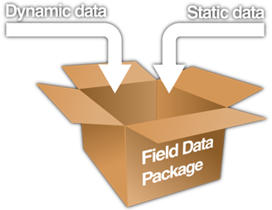

Figure 3‑3: Field Data Package

: Each dynamic data value carries its own value, source, owner and timestamp.

Each time an item in the dynamic data changes (with interval dependent on protocol), the item is overwritten accordingly and distributed over the network ten times a second.   
This updated data package is then compared with other versions of the same package on the network.

NavVision uses timestamps & sources to compare the values in the various package-versions, and selects the highest priority value as new value. The source of the value determines which new value is selected, followed by the timestamp of the readout.

Note that the procedure above is also used for distributing & synchronizing configuration (i.e. the static data of a field) over the entire network.

This means that any adjustment to a field configuration can be performed on any alarm panel with sufficient rights, and is picked up by all NavVision servers/clients.

After the current value is updated, it is compared with the alarm levels set in the static data of the same package. If the current value does not fall within the parameters set by these alarm levels, NavVision registers an alarm by setting the corresponding status in the dynamic data (e.g. too low alarm status) to "True" (with "False" meaning this status is currently not applicable).  
The data package is then again distributed over the network, and the cycle repeats itself.

## Standardized control functions

Within NavVision, every control request and command sent to the actuators is done by reading out the desired value in the dynamic data in a field.  
When a user has the right to modify the current value (per switch or slider), the desired value will be updated and distributed across the network. The Human Machine Interface (HMI) now shows both the current and desired value: a pending request is visible.

Once the protocol controlling this value notices the change in the desired value, it will send the request to the device. If the current and desired value still differs after a specific time, the request will be dropped and the instruments will show the current value (where required an alarm can be triggered).

## Serial connections to third party devices

The serial-to-LAN interfaces in NavVision systems are actually tiny computers. Given their programmable nature, these interfaces can be deployed with a large number of connected devices. The interfaces are equipped with 2 RS-232/422/485 serial ports and dual 10/100 Mbps Ethernet LAN ports, providing a versatile communication platform. The configuration of the devices is automatically done by NavVision.

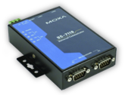

Figure 3‑4: Serial interface

## Built-in failure detection

The NavVision system offers built-in test facilities for the hardware and software components. This means that when a fault is detected, the operator will be notified immediately.

## Data logging

For the purpose of the technical monitoring of the installations on the ship, the condition of certain parts of the installation is recorded regularly. Owing to this it is possible to plan, for instance major, preventive repairs in periods that the ship is in the harbor.   
On top of that, data recording can be the help for the planning of normal maintenance on board of the ship.

The following data types are logged with a predefined sampling rate or on event.

|  |  |  |  |
| --- | --- | --- | --- |
| **Data** | **Sampling rate** | **Event** | **Data storage time** |
| Alarm events | - | Generate, acknowledge reset and rectify | Typically 180 days |
| Analogue values | 3 seconds | - | Infinite |
| Platform commands | - | On command | Typically 180 days |
| Platform parameters | - | On change | Typically 180 days |
| Running hours | 3 seconds | - | Infinite |
| Function group allocation | - | On change | Typically 180 days |
| Ship’s trip data | 3 seconds | - | Infinite |

Table 3‑3: Data logging

Sampled platform data is stored for an infinite period of time. The data storage time is only limited by hard disk size of the server.

Event data, such as alarm events and platform commands and settings, is saved with a maximum of one million records (one record per event or change). When the maximum number of records is reached, NavVision will start overwriting the log starting with the first record.

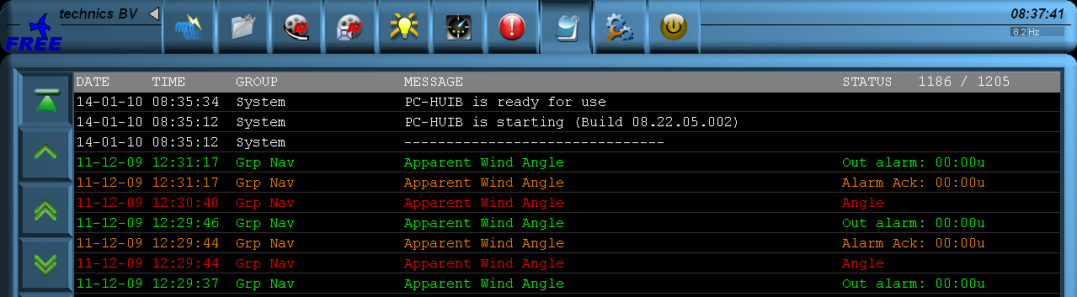

Figure 3‑5: Logbook

To distinguish the display information, different colours are used.

|  |  |
| --- | --- |
| **Colour** | **Detail** |
| White | Reports to indicate the system is busy processing data |
| Green | Reports to confirm a certain system task is successfully completed |
| Red | Reports to indicate a system error has occurred or an alarm is set off |
| Orange | Reports to indicate a red report has been confirmed or that a white or green report has been interrupted |
| Blue | Reports to indicate that parts of the system have been initialized. |

Table 3‑4: Display information colours

The different parts of the log-book are:

|  |  |
| --- | --- |
| **Button** | **Detail** |
| Navigation | With the scroll buttons you can navigate through the logbook. Via the upper scroll button the report-list automatically scrolls with every new incoming report (e.g. item 4). When this button is not activated, the list will freeze. With the 4 other buttons you can scroll up and down through the report-list. With the single arrow button you can shift one line at the time; with the double arrow scroll button you can shift a full page. |
| Alarm display | With the alarm buttons you can switch the reports regarding alarm warnings on or off. With the top button the reports regarding alarm stations can be turned on or off. With the lower button the reports regarding individual alarms can be turned on or off. |
| Communication & system display | With these buttons it is possible to turn on or off various reports in the report-list. The upper button controls the reports concerning the network connection. The second, centre button the reports regarding the serial connection are either switched on or off. The lower button is for turning on or off the reports regarding system in general. |
| Report list | This is the core of the logbook module. Here all system reports are being displayed. The latest reports are at the top of the list. The layout is identical to an actual log-book. |

Table 3‑5: Logbook buttons

Report information (see Figure 2‑5) is displayed as follows (from left to right):

* Date
* Time
* Group
* Message
* Report status.

# Sensors and controls

## Sensors

For I/O interfacing with NavVision, FT uses the modular and extendable I/O’s (WAGO). These I/O’s have been approved by organizations such as:

* Germanischer Lloyd (GL),
* Lloyds Register (LR),
* American Bureau of Shipping (ABS),
* Bureau Veritas (BV),
* Det Norske Veritas (DNV),
* Royal Institute of Naval Architects (RINA),
* Korean Certification (KR),
* Nippon Kodoshi Corporation (NKK).

### Analogue sensors

The following analogue sensor module types are mostly used.

|  |  |  |
| --- | --- | --- |
| **Sensor type** | **Description** | **Module series** |
| Analogue input | 0 - 20 mA and 4 - 20 mA | 750-452 750-454 |
| ± 10 VDC | 750-485 |
| Resistance temperature device | 750-461 |
| Analogue output | 0 - 20 mA | 750-550 |
| 0 - 10 V or ±10 V | 750-585 |

Table 4‑1: Analogue sensors

*NOTE: basically every GL approved WAGO module may be used.*

### Digital sensors

The following digital sensor module types are mostly used.

|  |  |  |
| --- | --- | --- |
| **Sensor type** | **Description** | **Module series** |
| Digital input | 24 VDC | 750-408  750-402  750-432 |
| Digital output | 24 VDC | 750-504  750-532  750-517 |

Table 4‑2: Digital sensors

*NOTE: basically every GL approved WAGO module may be used.*

### Serial sensors

For serial communication like ModBus, modules with GL approval are being used.

## Sensor priority

Sensor values will be processed according to a priority list. Main reason for this is that manually configured devices are more important than some NMEA data that is constantly present on the network.

Sensor values as indicated higher in the list (top) have a higher priority. If a sensor value is read twice by NavVision (through different input sources), then the sensor type input with the highest priority will be used. When the sensor values from the device with highest priority is no longer available, sensor values with the lower priority will be automatically chosen.

|  |  |
| --- | --- |
| **Priority level** | **Device** |
| 1 | WAGO inputs |
| 2 | Electrical systems |
| 3 | Tank monitor |
| 4 | Draft sensors |
| 5 | Generic engine data |
| 6 | NMEA |
| 7 | Misc. communication |
| 8 | WAGO output |

Table 4‑3: Sensor priority list

## Sensor calibration

To ensure sensor accuracy and system integrity sensors need to be calibrated. Look-up tables will be provided for typical sensor and tolerance types. A maximum of 16 values can be defined.

## Sensor alarm settings

For instruments it is possible to set the following alarms:

|  |  |
| --- | --- |
| **Sensor alarm type** | **Detail** |
| Low | Warning alarm. |
| Too low | Critical alarm. Can invoke automatic reduction of system(s). |
| High | Warning alarm. |
| Too high | Critical alarm. Can invoke automatic reduction of system(s). |
| Failure | Warning alarm. |
| Message | User message. Can be set per user and does not affect the system’s alarm settings. |

Table 4‑4: Sensor alarms

### Sensor alarm groups

Each sensor is linked to two alarm groups i.e.:

* A warning alarm group
* A critical alarm group.

The following alarm groups are always visible;

* Stop
* Slow down
* Common (all others are freely configurable).

# I/O-stations

## Components

An I/O-station is a rack or cabinet that contains decentralized I/O components. They generally consist of the following components.

* Local Processing Unit (LPU)
* Serial interface (INT)
* Network switch (NWS)
* Power supply (DC/DC converter)

### Local Processing Unit

A Local Processing Unit (LPU) configuration and part of an I/O-station consists of the following:

* Head station (coupler) which processes I/O;
* Power supply filter
* Power supply fuse
* Various I/O modules
* Terminator.

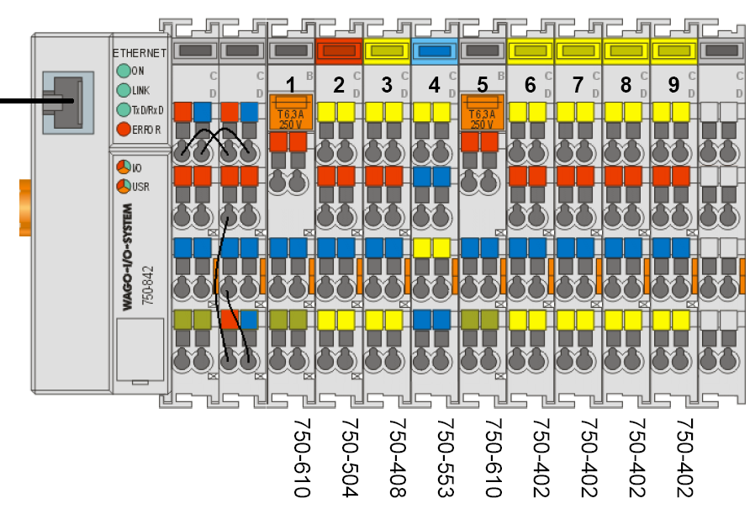

Figure 5‑1: Local Processing Unit

### Network switches

The network switches (NWS) used by Free Technics (FT) are suitable for use in industrial environments, and support 10 MBit/s and fast 100 MBit/s Ethernet.   
The switches are used for setting up small Ethernet/Fast Ethernet networks quickly or for expanding existing networks. They have 5 or 8 twisted pair ports with standard RJ-45 connectors.

Switches are installed on to standard DIN rails. Each port sets itself automatically to 10Base-T or 100Base-TX and to full or half duplex operation.

An additional contact in the terminal block allows for reading in the status messages of the units as process data, for monitoring of operating states.

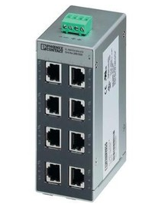

Figure 5‑2: Network switch

### Power supply

24 VDC power supply is to be supplied to the I/O-station redundantly, ensuring the reliability of the network and the system. A redundancy module is used to automatically switch between mains in real-time, when one of the mains is interrupted (see Appendix A).

# Workstations

## Workstation versions

Within the NavVision system several Workstation versions are used i.e.:

### Workstation

The Workstation is a fully solid state and embedded software based control and monitoring station. All Workstation’s can perform various roles (server, (failsafe) client and/or alarm panel), and are able to automatically switch roles when needed. As a minimum, there are always two Workstation’s present in the system, one acting as a main server and one acting as a backup.

These systems are suitable for life at sea, as shown by the following features:

* Shock proof and solid state design
* Useful in areas where low power/high performance computing is essential
* Useful in space critical installations.

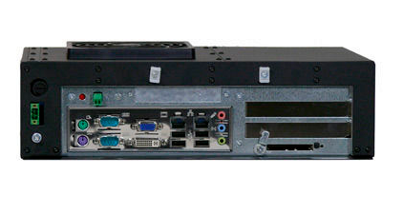

Figure 6‑1: typical Workstation

### Duty Alarm Panel

A Duty Alarm Panel (DAP) is a panel used to display any alarm that might be active at that time. It uses a 6.5” touch screen which allows for direct interaction with the alarm panel and is used for navigating through present alarms incl. silencing them. The DAP is driven by a small industrial computer running an embedded operating system. By default, these are used to switch between a manned and unmanned machinery space and silence alarms.

Each individual DAP has individual settings i.e.:

* Display of alarm status
* Display of new alarms
* Silencing alarms locally
* Call functions

These rights are configured per group and per alarm station.

For instance: when a specific alarm is initiated, the DAP checks whether it has access to the relevant rights in the assigned group and will act correspondingly.



Figure 6‑2: Duty Alarm Panel (DAP)

### Operating system

All Operator Work Stations run a customized Operating System (OS), based on Windows CE embedded. For each different type of computer, FT creates a tailor-made OS for the specific hardware of the computer. In comparison with standard Windows (XP or Vista) installations, embedded environments offer these benefits:

* Increased stability due to a minimum of running processes
* Virus-proof through read-only access: the OS reverts to original state after reboot
* Small disk-space requirement by leaving out unnecessary software
* Fast boot-time because less processes are loaded upon boot
* Increased performance because only vital processes are running
* High energy efficiency due to the light load on the inner hardware.

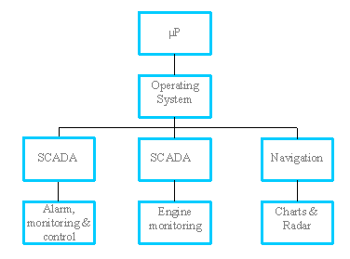

Figure 6‑3: Traditional OS structure

*NOTE*

*Navigation, charts and Radar are optional and are not in the scope of this document.*

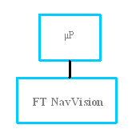

Figure 6‑4: NavVision embedded OS structure

### Connection to I/O-stations

All Workstations are connected to the LAN and can be situated in machinery control rooms, bridges or in cabins and mess rooms. The Ethernet network is based on a redundant network topology, ruling out single points of failure as much as possible. The redundant Ethernet network and I/O hardware collects data via servers and distributes all data to any clients to be used as a Workstation .

### Power supply

A Workstation operates on 24 VDC (see Appendix A).

# Human Machine Interface

The Workstation Human Machine Interface (HMI) function enables to visualize the actual state of a physical platform object, by colour and/or shape animation. Moreover as soon as an undesirable platform state is detected the relevant operator will be notified by means of an audible alarm signal.   
Messages concerning the alarm are displayed by the alarm presentation. The HMI also supports remote platform control signals in case operators control the platform via the Workstation . The NavVision HMI consists of the following features i.e.:

## Taskbar

NavVision main User Interface (UI) element is the taskbar, positioned on top of the main screen. The taskbar is home to the shortcuts to various viewers and time.

In addition, whenever an alarm is registered, the right most portion of the taskbar turns a bright red and shows a list of the alarm(s) currently active. A single click on this portion links to the extensive alarm viewer showing the data belonging to each alarm item such as time, alarm group, status and duration.

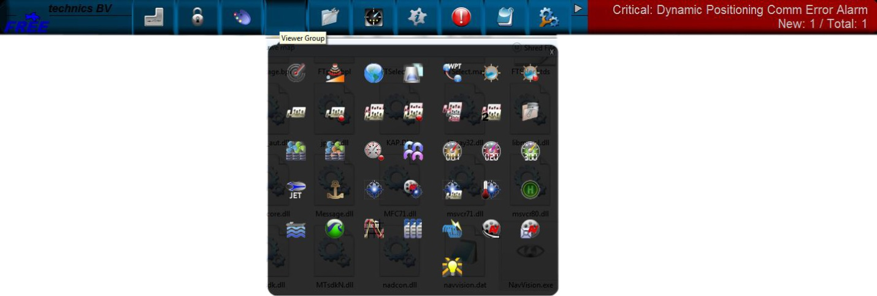

Figure 7‑1: NavVision taskbar

Features:

* Scroll feature (hold or click the mouse pointer on the taskbar arrow until the desired button is found)
* By clicking a particular button, you will open the corresponding module/viewer
* In case more than one monitor (MTR) on one PC is used, a monitor for a particular viewer must be selected. If no screen is chosen, a vacant screen will be selected at random.
* The selected and activated button will obtain a green spot, to indicate that the corresponding module is activated
* A module can be closed by clicking the corresponding button again. In case one screen is used, a module will close by clicking a new button
* When several screens are available, it will be possible to display the viewers of the modules on these screens;
* On the right-hand side of the taskbar there is an alarm zone that will display the active alarms. One or two alarms will directly be visible. In case there are more than two active alarms, they will alternately appear (scroll) on the taskbar;
* The alarm report screen can be opened by clicking the alarm zone.

### Mimics and screens

The system’s mimic presentation function provides schematic and graphical overviews of the vessel’s systems like navigation lights, electrical, piping and hydraulic overviews etc.

The screens and mimics presentations are automatically updated with live data of the platform components illustrating components and/or system status (enhances smooth operation of instruments and images).

Via these screens and mimic pages, the operator is able to monitor and control the vessel by using the trackball or touch-screen as a pointing device by selecting elements and their associated commands.

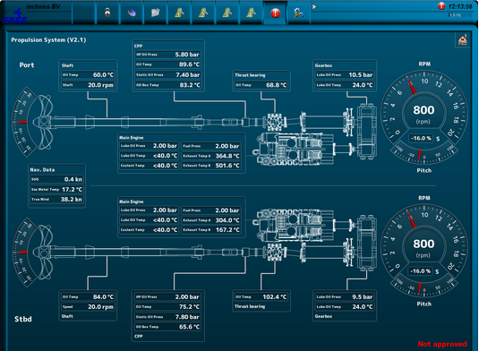

Figure 7‑2: Example mimic

## User rights

NavVisionhandles control rights by using log-in credentials (username and password), and assigning rights to these credentials. These rights limit access to the system's configuration, therefore ruling out any edits that may harm the system made by unauthorised crewmembers.

Users can be added, edited or removed. Adding, editing and removing users, together with assigning their rights, can only be done by an administrator, i.e. a top-level user.

For every profile made, permissions can be set. The system is delivered with three pre-configured user-profiles, namely:

1. *Administrator*: has all rights;
2. *Guest*: can only use the available viewers;
3. *Operator*: can only alter display mode and/or units.

Logging in is required upon system start-up. After start-up, users can log off and in using a dedicated button on the taskbar.

The rights (configurable) for NavVision are as follows:

Table 7‑1: NavVision rights

|  |  |
| --- | --- |
| **Rights** | **Effect of rights** |
| Administrator rights | Full access to the system's configuration parameters |
| Personal alarm settings | Set alarms on the particular DAP[13], for this user only |
| Certified alarm settings | Configuration of global alarm stations |
| Layout instruments | Edit instrument's display mode (digital, analogue, graphic) |
| Configuration of instruments | Change instrument's assigned field |
| Settings of logging | Enable/disable logging of fields |
| Able to close application | Right to shut down the panel |
| Settings of sliders | Changing the value of sliders |
| Edit layout viewer | Ability to edit a mimic of the layout viewer |
| Settings → Field settings | Access to the field settings page |
| Settings → Preferences | Access to the preferences page |
| Settings → Taskbar | Access to the taskbar page & configuration of the selectable & default viewers |
| Settings → Configuration | Access to the configuration page |

### Instruments and indicators

Instruments and indicators are distinguished as follows:

|  |  |  |
| --- | --- | --- |
| **Feature** | **Instrument** | **Indicator** |
| Display configuration | Yes | No |
| Alarm settings | Yes | No |
| Unity select | Yes | No |
| Choice of instrument | Yes | Yes |

Table 7‑2: Configuration features (instruments and indicators)

### Analogue, digital and graphical instruments

*: The following examples are deprecated, but still in a majority of systems worldwide. The next generations of instruments will be solely represented in mimics which will be discussed later.*

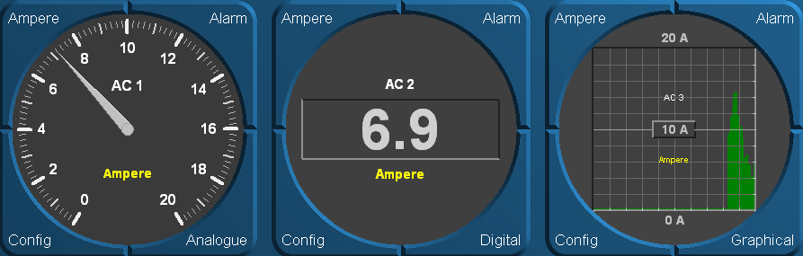

Figure 7‑3: Analogue/digital/graphical instrument

1. **Unity select**  
   All represented data comes with a certain unity e.g. m/s, km, nm, KN etc. These initial values (default values) can be set at default. However, it is also possible for the user to directly adjust an indicator. Click the corresponding display button to adjust the unity.
2. **Setting of alarms**   
   By means of the “Alarm” button it is possible to adjust the alarm angle or alarm settings. For example, course or wind angle can be set; the speed or depth indicator can be adjusted.
3. **Display configuration**   
   Via the Graphic button the indicators (analogue or digital) can be set into a different display mode. The wind direction can also be set to close hauled. Click the button to adjust the mode of display.
4. **Choose instruments**   
   The “Config” button allows you to alter the type of instrument by selecting a different measurable value from the list. This configuration list is integrated for all instruments. In the next paragraph the operation will be explained.

### Indicators

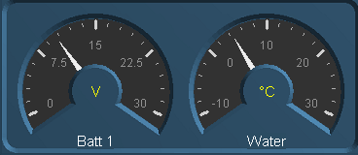

Figure 7‑4: Indicators

The indicators have the same functionality as the analogue instruments, only the graduation-scale differs. As a rule, indicators are being used for those values which do not require a precise reading, like e.g. voltages and pressures. The advantage of indicators over other instruments is that they take up less space. It is possible to change the mode of display of a certain indicator by clicking the right mouse button. Then the configuration list with system parts appears from which the operator can choose.

### Bar graph display

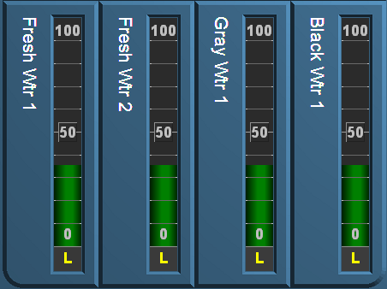

Figure 7‑5: Bar graph display

The fuel tank level can be displayed with bar graphs. Like other instruments bar graphs are configurable (other values). The bar graph indication runs vertically, from bottom to top, to indicate the appropriate level.

The coloured segments (value adjustable) indicate the current level. The displayed subject part can be changed. Different systems to be monitored can be selected in the configuration list.

### Diagrams

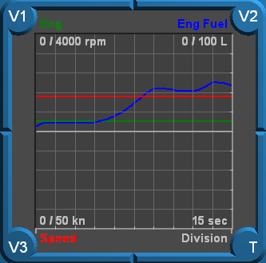

Figure 7‑6: Trend diagrams

By means of diagrams parts of the system can be displayed over a longer period of time.

With the diagram instrument different types of data can be displayed at one time. With the buttons V1, V2 and V3 a data selection can be made. The time-scale of the diagram can be changed by clicking the T-button. Each click will enlarge the scale until it reaches the smallest scale of 15 s. The largest scale is 24 hrs.

### Buttons/switches

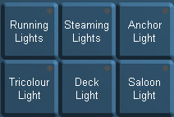

Figure 7‑7: Buttons

With these buttons, systems can be switched on or off or changes can be made to certain parts of the system. An operator can use the left mouse button to activate a button, by clicking it again, the button will be disengaged.

A small green spot in the relevant button lights up, indicating that the corresponding application is active. As long as the button lights up blue, it means that the software is processing data in order to activate the application. Details of this list are described in the “Config list” (see chapter 7.3).

### Meters

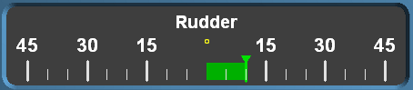

Figure 7‑8: Meter

Meters are used for position information (e.g. rudder position). A deflection to the right and the left are compared to a neutral position (centre of the meter).

## Config list

Basically any instrument allows you to display any type of data. Changes can be done by an operator with sufficient user rights. To change, press the config button (see paragraph 7.2.2) of a particular instrument within the “Config list”, or click the right mouse button on the instrument when no button is visible. The following window appears:

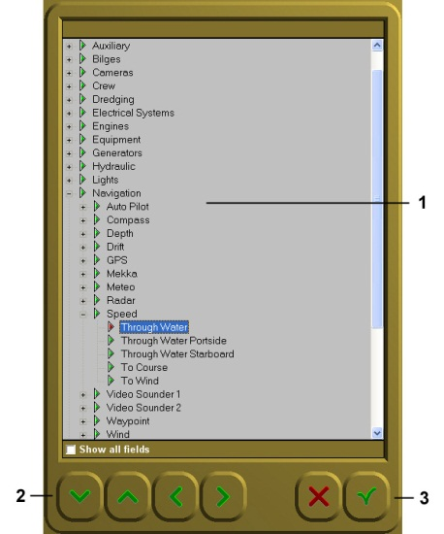

Figure 7‑9: Config list

From this list (1) you can select the type of data you wish to direct to a certain instrument. At the bottom of the list there is a check-box. In case this check-box is not ticked, only those groups will show of which data is being communicated. In case the check-box is ticked, all available groups will then be shown.

## Layouts

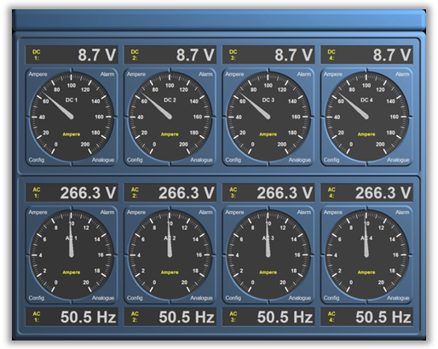

Figure 7‑10: Electrical distribution mimic

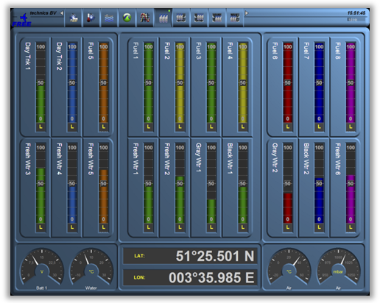

Figure 7‑11: Tank level mimic

## Colour usage

Platform statuses are preferably to be visualized to remote operators by using animation i.e. by changing the relevant symbol colour and/or symbol shape an operator will be able to interpret statuses much easier rather than by *reading text* strings or by interpreting numbers. This chapter defines colours and shapes relevant for the majority of platform objects frequently being used on a ship’s platform.

# Mimics

## Introduction

Mimics are the new way to represent all the data in NavVision. It is a freely adjustable HMI that you can use for any kind of representation, as well monitoring as control or a combination of these.

## Colour coding

Mimics will use the following colour set for pipeline circuits and static (non-animated) symbols:

|  |  |  |  |  |
| --- | --- | --- | --- | --- |
| **Colour** | **RGB** | | | **Medium description** |
|  | **RED** | **GRN** | **BLU** |  |
| **Brown** | 195 | 65 | 0 | Fuel oil |
| **Olive** | 128 | 128 | 0 | Lubrication oil |
| **Dark green** | 0 | 128 | 0 | Sea water, ballast water, fire main system |
| **Teal blue** | 0 | 128 | 128 | Low temperature fresh water (cooling water and potable water) |
| **Aqua blue** | 0 | 255 | 255 | High temperature fresh water (cooling water and potable water) |
| **Grey** | 128 | 128 | 128 | Bilge water, hydraulics, grey/black water |
| **Bright green** | 0 | 255 | 0 | Electrical distribution – Medium Voltage |
| **Orange** | 255 | 102 | 0 | Electrical distribution – High Voltage |
| **White** | 255 | 255 | 255 | Compressed air, ventilation air, exhaust gas |

Table 8‑1: Colour markings of pipes

### Symbols

To learn about animated symbols you must be familiar with the basics of element processing first. Platform objects can be classified regarding their electrical interface and functional behavior into so called, element types.   
In this way it is possible to distinguish sensor types, valves, motors etc. Once classified into element types it is quite easy to specify the applicable symbols since the element type identifies the relevant monitoring and control abilities as well.

However mimics not only comprise of animated objects. For instance in case a platform object is not involved with alarm monitoring and control features at all then from PMS[14] point of view it makes no sense to comprehend this object.   
Still these objects might be displayed in mimics as static (i.e. not animated) to improve clarity. This set of static symbols is based on nowadays widely accepted icons being used in system diagrams and P&ID[15] drawings. Static symbols will be drawn in the colour of the applicable medium.

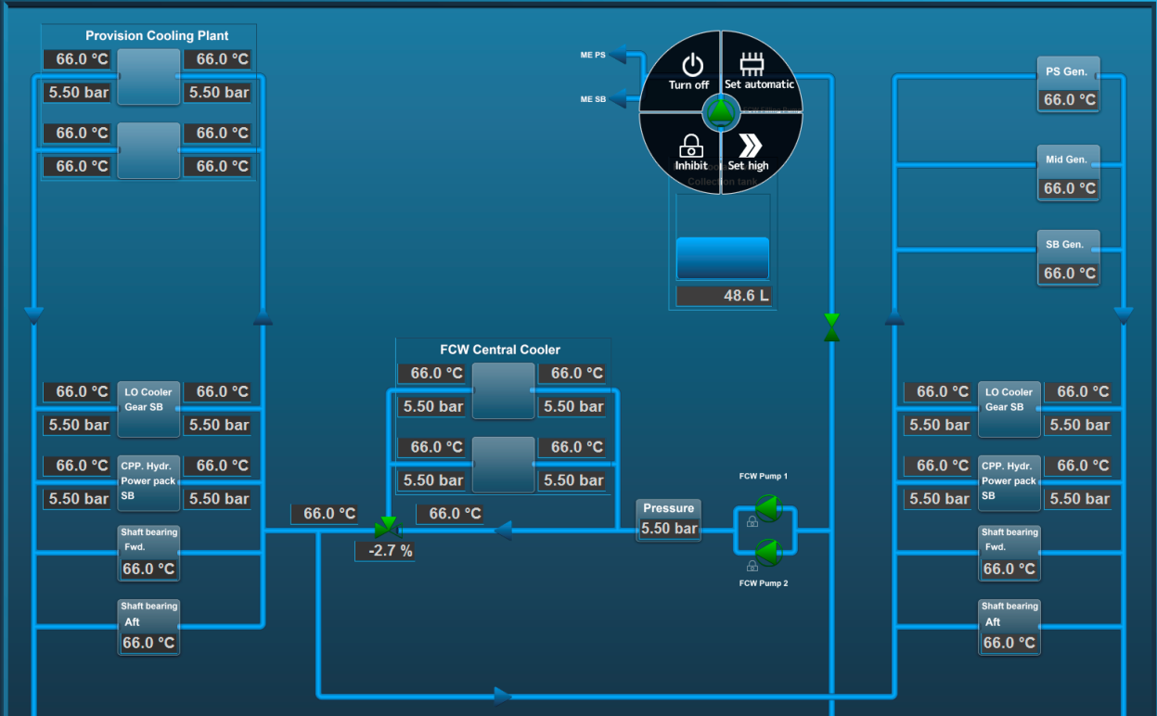

Figure 8‑1: Mimic layout

### Control elements

Control elements are used to interface a wide range of “Control” devices like pumps, fans, valves, generators, etc. via their relevant starter unit. Since these element types are suitable to process a wide range of components, several symbols are defined to represent each type.   
Colour animation is used to show the actual element status.

Chevrons, a single filled chevron (arrow) for low - and a double filled chevron (arrow) for high speed, show the difference between a control element running at high speed and a control element running at low speed. Chevrons without filling indicate an off condition.

|  |  |  |
| --- | --- | --- |
| **Status** | **Control element** | **Symbol** |
| Operable in two speeds, system off | Double chevron (no fill) |  |
| Operable in two speeds, system running at low speed | Double chevron (single chevron filled) |  |
| Operable in two speeds, system running at high speed | Double chevron (double chevron filled) |  |
| Operation is disabled (local control only or controlled by other WORKSTATION) | Padlock |  |
| Manual operation (controlled remotely) | Hand |  |
| Automatic operation (controlled by ACS[16]) | Chip |  |

Table 8‑2: Control element status

Table 8‑3: Colour codes (control elements)

|  |  |
| --- | --- |
| **Colour** | **Description** |
| **Grey** | Control element off (stopped), device is ok |
| **Green** | Control element on (running), device is ok |
| **Orange** | Control element in warning condition |
| **Purple** | Control element defective |
| **Red** | Control element in alarm condition |

### Pump and generator control elements

|  |  |  |  |
| --- | --- | --- | --- |
| **Centrifugal pump** | **Piston pump** | **Generator** | **Status description** |
|  |  |  | OFF |
|  |  |  | ON (condition ok) |
|  |  |  | ON, WARNING condition |
|  |  |  | ON,  DEFECTIVE condition |
|  |  |  | ON,  CRITICAL condition |

Table 8‑4: Control elements and colour animation

### 3- Way valve control element

|  |  |  |  |
| --- | --- | --- | --- |
| **3-way valve OFF** | **Status description** | **3-way valve ON** | **Status description** |
|  | 3-way valve OFF (status indication only) |  | 3-way valve ON (status indication only) |
|  | 3-way valve OFF, AUTO  (control by AMCS[17]) |  | 3-way valve ON, AUTO  (control by AMCS) |
|  | 3-way valve OFF, AUTO  (local control) |  | 3-way valve ON, AUTO  (local control) |
|  | 3-way valve OFF  (local control) |  | 3-way valve ON  (local control) |
|  | 3-way valve OFF, MANUAL  (controlled by AMCS) |  | 3-way valve ON, MANUAL  (controlled by AMCS) |
|  | 3-way valve OFF, MANUAL (local control) |  | 3-way valve ON, MANUAL (local control) |

Table 8‑5: Control elements with status indication

|  |  |
| --- | --- |
|  | Centrifugal pump ON,  Operable in two speeds, system off |
|  | Centrifugal pump ON,  Operable in two speeds, pump running at low speed |
|  | Centrifugal pump ON,  Operable in two speeds, pump running at high speed |

Table 8‑6: Control elements with speed indication

|  |  |  |
| --- | --- | --- |
|  |  | Fan OFF and ON |
|  |  | 2-way valve OFF and ON |
|  |  | Check valve OFF and ON |

Table 8‑7: Other control elements

## Functional description

### Measuring and control of Fresh Cooling Water (FCW) temperature

The description of the sequence below serves as a model for process measuring and control functions. The three-way valve regulates the temperature of the FCW automatically.

|  |  |  |
| --- | --- | --- |
| **Item description** | **Sensor type** | **Condition** |
| Three-way valve central cooler position indication | AI | Status |
| Three-way valve central cooler position control | A0 | Status |
| Three-way valve central cooler error signal | DI | Alarm |
| Three-way valve FCW inlet temperature | AI | Status |
| Three-way valve FCW outlet temperature | AI | Status |

Table 8‑8: I/O declaration (FCW temperature)

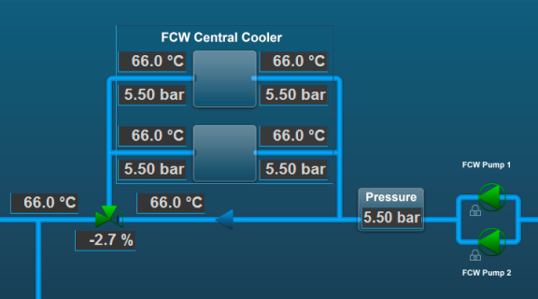

Figure 8‑2: Measuring and control of FCW temperature

### Alarm and monitoring of main engine exhaust gas system

The description of the sequence below serves as a model for alarm and monitoring functions with programmed calculation.  
By means of NiCrNi sensors the exhaust gas temperature of all cylinders will be measured.

Alarms are generated when certain cylinder temperatures are reached.

|  |  |  |
| --- | --- | --- |
| **Item description** | **Sensor type** | **Condition** |
| Engine temperature exhaust bank cylinder A1 | AI | Alarm |
| Engine temperature exhaust bank cylinder A2 | AI | Alarm |
| Engine temperature exhaust bank cylinder A3 | AI | Alarm |
| Engine temperature exhaust bank cylinder A4 | AI | Alarm |
| Engine temperature exhaust bank cylinder A5 | AI | Alarm |
| Engine temperature exhaust bank cylinder A6 | AI | Alarm |
| Engine temperature exhaust bank cylinder A7 | AI | Alarm |
| Engine temperature exhaust bank cylinder A8 | AI | Alarm |
| Engine temperature exhaust average value | Analogue | Alarm |

Table 8‑9: I/O declaration (engine exhaust gas system)

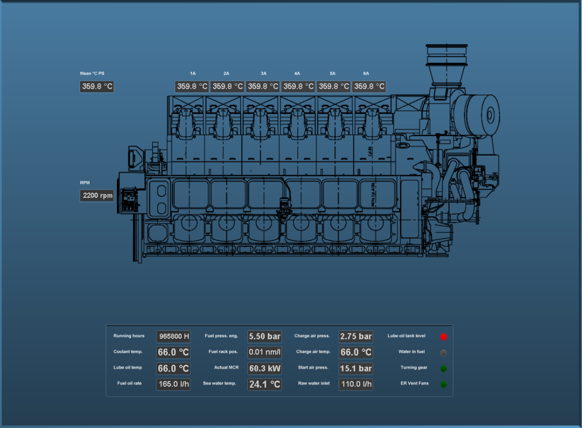

Figure 8‑3: Exhaust gas temperature measurement

### Tank measurement system

The description of the sequence below serves as a model for alarm and monitoring functions with programmed calculation.

|  |  |  |
| --- | --- | --- |
| **Item description** | **Sensor type** | **Condition** |
| Fuel tank level input | AI | Alarm |
| Fuel tank level output | AI | Status |

The calculation will be done in accordance with the tank tables supplied by the yard.

Typical alarm set points are: Low = 5%, High = 95%, Too high = 98%.

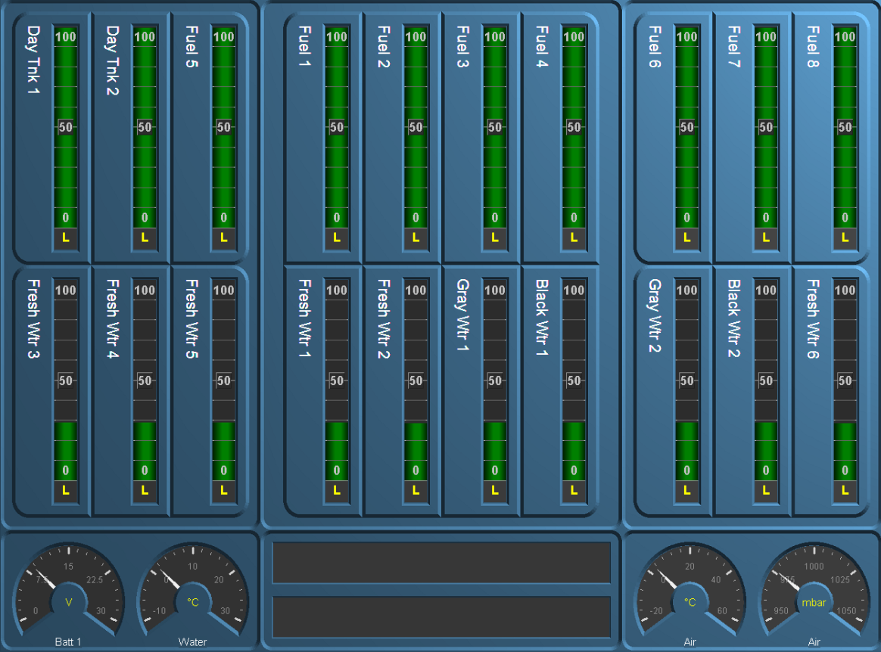

Figure 8‑4: Tank measurement

# Duty alarm system

## General

The duty alarm system is used for the transfer of alarms to the technical crew in case of an unattended machinery space. The duty alarm system will be configured from a particular Workstation .   
The duty alarm system provides unambiguous audio visual annunciation of alarms and warnings via a dedicated banner located at the top of the alarm panel screen.

A watch and call system extends the central alarm system to engineers' cabins and public areas when machinery spaces/control rooms are unattended.

The duty alarm system distinguishes two different alarm modes i.e.:

* Attended (see chapter 9.1.1)
* Unattended (see chapter 9.1.2).

Alarms will be distributed to all Duty Alarm Panels (DAPs), servers and clients.

### Attended alarm mode

NavVision will transfer the alarm to the activated location.

In case of an attended or manned machinery space this location will be the:

* Engine Control Room (ECR)
* Accommodations (e.g. mess room and public areas).

### Unattended alarm mode

In case the operator is not present at the Workstation in-control, but making his round to one of the machinery spaces or doing routine maintenance. Within this period of time, alarms that are present are visible on all Duty Alarm Panels (DAPs).

The “Unattended” mode can be activated on the Workstation that has control over the sensor alarm group. Activation of the unattended machinery space mode can only be done when all alarms of “Unattended” sensor alarm groups are acknowledged.

NavVision will direct the alarm to the activated location.

In case of an unattended or unmanned machinery space this will be:

* The engineer on-duty
* Accommodations (e.g. mess room and public areas).

When a sensor alarm group is unmanned in “Unattended” mode, new alarms are indicated on the DAP of the engineer. On the panels, the alarm sounding (horn/buzzer) can be silenced (only local), but the alarms still need to be acknowledged on the Workstation within the relevant technical area.

If alarms are not acknowledged within a specific period of time on the Workstation in-control, the “General Engineers Alarm” (GEA) is invoked, independent from the “Attended/Unattended” mode. Once the GEA goes off, the alarm will sound on all alarm stations

### How an alarm is displayed

|  |  |
| --- | --- |
| **Panel** | **Alarm displayed** |
| Duty Alarm Panel (DAP) | On main screen |
| Workstation | On taskbar  On alarm viewer  In logbook  On any mimic showing the field-in-alarm |

*NOTE*

*The alarm viewer on the WORKSTATION uses the same layout as the DAP, thus making it easier for an operator to understand and operate the screen.*



Figure 9‑1: Alarms on alarm viewer and taskbar

### How to acknowledge an alarm

The alarms must be acknowledged on the Workstation in the Engine Control Room (ECR) by means of:

* Double clicking the corresponding alarm line (alarm viewer)
* Double clicking the field (when red) in the MIMIC showing the field-in-alarm.

### When an alarm is not acknowledged within a specific period of time

The General Engineers Alarm will sound on all alarm stations, until it is accepted / acknowledged, in which case the alarm goes off.

Any unacknowledged alarm is always shown on top of the acknowledged alarms of the alarm viewer (incl. DAP) and will be flashing red.

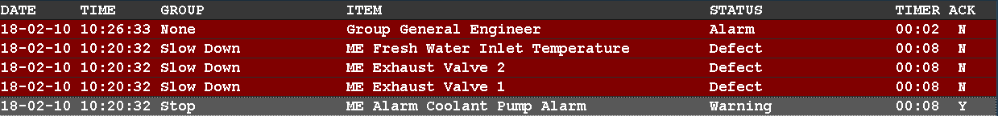

Figure 9‑2: One acknowledged and three unacknowledged alarms (incl. GEA)

### How to silence an alarm (not at ECR)

You can silence an alarm on all other locations.

This will silence the alarm buzzer for 3 minutes, but will not acknowledge the alarm.

The engineer is required to go to the Engine Control Room (ECR) to acknowledge the alarm.  
On other systems, silencing the alarm is also called an “audible acknowledge”. We will however use the term “silencing” throughout all of our documentation.

### When will an alarm disappear

An alarm will disappear only when rectified AND acknowledged. Acknowledged alarms will show in the normal instrument colour.

### Duty Alarm Panel (DAP)

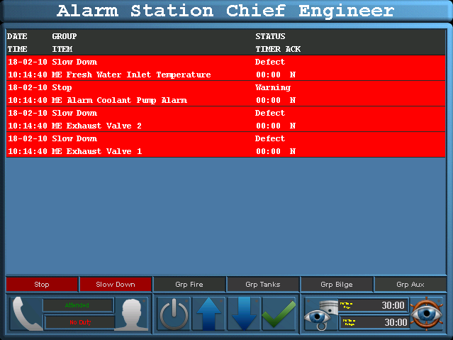

Figure 9‑3: Duty Alarm Panel (DAP)

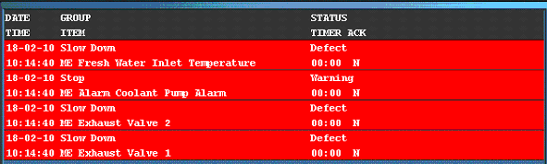

Figure 9‑4: Alarm and status area

°

Figure 9‑5: Alarm groups



Figure 9‑6: Bridge watch

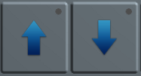

Figure 9‑7: Operating buttons

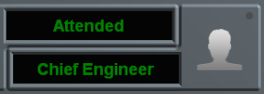

Figure 9‑8: On duty indication

م°

Figure 9‑9: Bridge watch safety timer

م°

Figure 9‑10: Engine room watch safety timer



Figure 9‑11: Engine room watch button



Figure 9‑12: Call button



Figure 9‑13: Acknowledge button

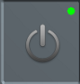

Figure 9‑14: Panel active button

## Duty Alarm Panel functionalities

|  |  |
| --- | --- |
| **Functionality** | **Description** |
| Alarm & status area  (see Figure 9‑4) | In the “Alarm & status area” the alarm summary, alarm history and tag details will be presented. The alarm summary will present the active alarms with time stamps and values.  The alarm history will present the alarms with time stamp of the alarm occurrence, acknowledge and gone date and time. |
| Operating buttons  (see Figure 9‑7) | The “Operating buttons” (arrow up & down) are used for scrolling through the alarm page(s). While pressing the “Enter” button an alarm history, tag details and alarm summary menu is shown. |
| On duty indication  (see Figure 9‑8) | The “On duty indication” indicates which engineer is on duty. The panel that is in the operational mode “On duty” the Field “On duty” will light up. In addition, the field that defines the engineer will illuminate (1st, 2nd, 3rd etc). The panels that are not on duty will indicate the engineer on watch. |
| Alarm groups  (see Figure 9‑5) | The “Alarm groups” button indicates if an alarm is active within a critical group. |
| Failure indication  (see Figure 10‑1) | In case of a failure (network) an audible alert (buzzer) is triggered. The text “Connecting” appears on the display to indicate the lack of connectivity. The alert can be silenced by touching the display screen. |
| Bridge watch safety timer[18]  (see Figure 9‑10) | In case of a one man bridge, the bridge watch alarm can be enabled for safety purposes. The bridge watch safety timer must be reset within a specific amount of time (using the reset button of an alarm panel on the bridge), else a General Engineers’ Alarm (GEA) is invoked on all stations. |
| Engine room watch alarm  (see Figure 9‑11) | The Duty Alarm Panel indicates whether the machinery space is “Attended” or “Unattended”. |

Table 9‑1: Duty Alarm Panel functionalities

## On duty select procedure

An engineer on duty can be selected on duty from the allocation control button on the Duty Alarm Panel (DAP). The engineer will be warned when an alarm is present in one of the “Unmanned” alarm groups. Using the alarm panel of the engineer on duty, the engineer is notified of new alarms. This is done by warning light, buzzer and/or on-screen functions. Alarms are always represented on the screen.

The duty alarm system sends alarms to the responsible persons in case of incorrect situations whenever the machinery spaces are unattended. The release procedure for duty alarms will be done (before leaving the area) at the main Workstation in the Engine Control Room (ECR).

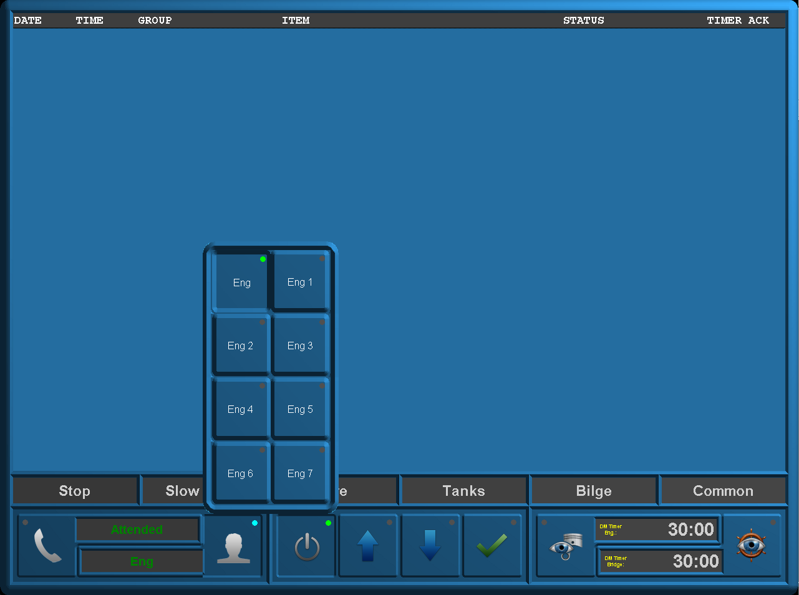

Figure 9‑15 Duty Alarm Panel (on duty select)

## Alarm acknowledge procedure

If during watch free operation an alarm occurs the normal procedure will be that the engineer on duty will receive an optical and acoustic alarm in his cabin. Accordingly he must acknowledge the alarm on his panel.

The alarm itself is still in the status not acknowledged. The engineer on duty must go to the ECR, to acknowledge the alarm and solve the problem in the control room.

When the engineer on duty ignores the alarm in his cabin, a repeat alarm function will be activated. This means, after a specific period of time the duty alarm system generates a General Engineer’s Alarm (GEA) on all stations.

## Call function

From the Duty Alarm Panel (DAP) it is possible to call for a specific engineer, bridge or all engineers (see Figure 9‑16).

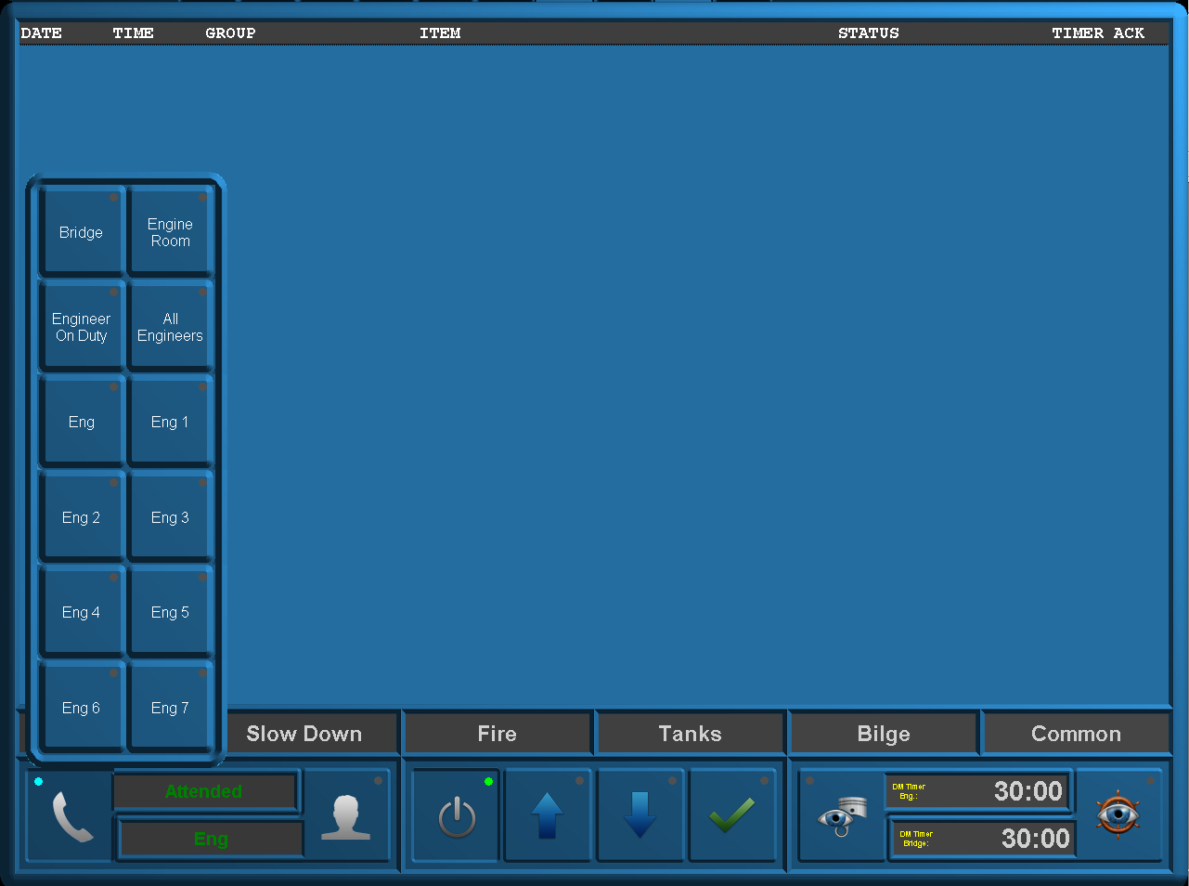

Figure 9‑16 Duty Alarm Panel (call function)

# Personnel alarm

## General

A personnel alarm provides a safety timer (see Figure 9‑9 and Figure 9‑10) for personal protection, used when a single person works in an unattended area. The personnel alarm consists of:

* A release station
* An acknowledge station

### Release station

The release station is used to indicate whether a machinery space is “Attended” or  
“Unattended”. The release station consists of the following buttons i.e.:

* Timer + key switch (ON/OFF position)
* A green “SYSTEM ON” light (illuminated when dead man system is on).

|  |  |
| --- | --- |
| **Button** | **Detail** |
| Timer | The safety timer can be deactivated (disabled) by using the key switch (specifically used when the machinery space is already occupied).  Key switch in OFF = SYSTEM ON light is off  Key switch in ON = SYSTEM ON light is on (green) |

Table 10‑1: Release station buttons

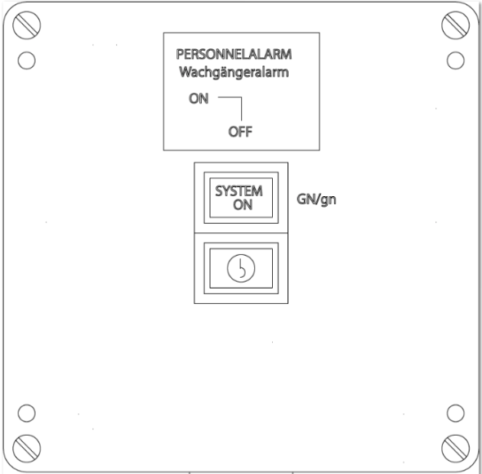

Figure 10‑1: Release station

### Timer reset station

In order to acknowledge alarms to persons on duty a timer reset station is used.   
The timer reset station consists of a single button, the “Timer reset” button.   
This button has a combined function i.e. button and lamp.   
Pressing the button resets the timer (see Figure 10‑2). Once the button is depressed a yellow light comes on, to indicate that the personnel alarm system has been switched on.

The timer reset station consists of hardwired buttons with LED[19] lighting.

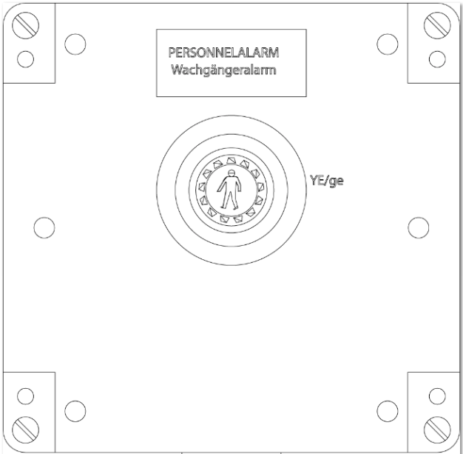

Figure 10‑2: Timer reset station

## *: A personnel alarm system can also consist out of mushroom buttons for the timer reset and entrance panels for the machinery space. The on/off function will then be performed on screen with a code*Alarm monitoring and control process

|  |  |
| --- | --- |
| **Step** | **Detail** |
| 1 | The Alarm, Monitoring and Control System (AMCS) detects when a person enters a machinery space via the key switch on the “Release station” in or near the machinery space. |
| 2 | After 27 minutes an audible or visual alarm will be initiated by the system in the appropriate machinery space to prompt the engineer to reset the safety timer. |
| 3 | During each period of 30 minutes the person working alone in that space must reset the safety timer to confirm his presence/well-being. A “Reset” command must be given via the reset button on the “Timer reset station” in that particular machinery space.  Each space has its own safety timer. |
| 4 | If the “Reset button” is still not pressed within 3 minutes after the warning, a general alarm will sound on the Duty Alarm Panels (DAPs). |

Table 10‑2: Alarm monitoring and control process

Appendix A - System architecture

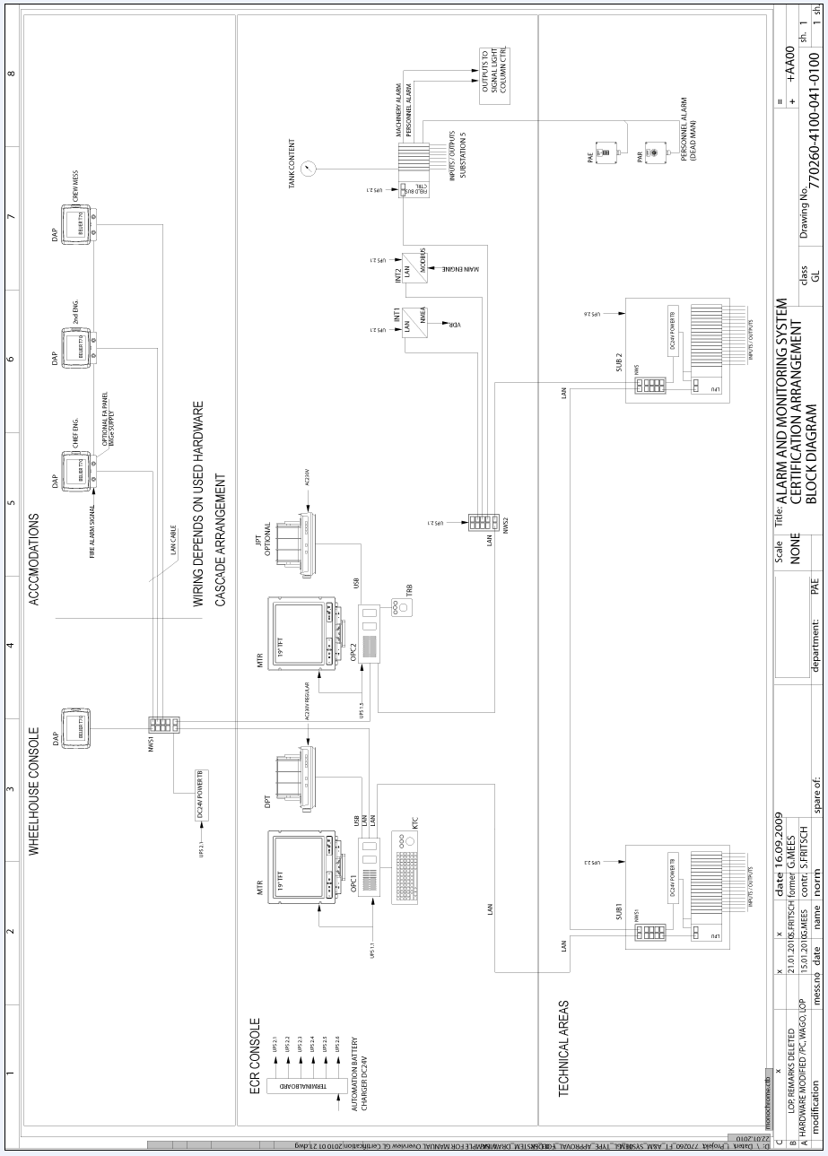

# Appendix B - Technical data sheets

Separately provided.

1. AUT = Automation systems
2. I/O = Input/Output
3. MAC = Media Access Control (hardware address)
4. TCP / UDP = Transmission Control Protocol / User Datagram Protocol
5. Mod bus = Serial communications protocol
6. CAN bus = Controller Area Network serial bus system
7. J1939 = Real-time CAN solution for heavy duty applications
8. NMEA = National Marine Electronic Association
9. IMO = International Maritime Organization
10. SOLAS = Safety of Life at Sea
11. VDR requirements
12. Being an OPC or DAP
13. DAP = Duty Alarm Panel
14. PMS = Platform Management System
15. P&ID = Piping & Instrumentation Diagram
16. ACS = Automation Control Sequences
17. AMCS = Alarm, Monitoring and Control System
18. Not part of the type approval process.
19. LED = Light Emitting Diode